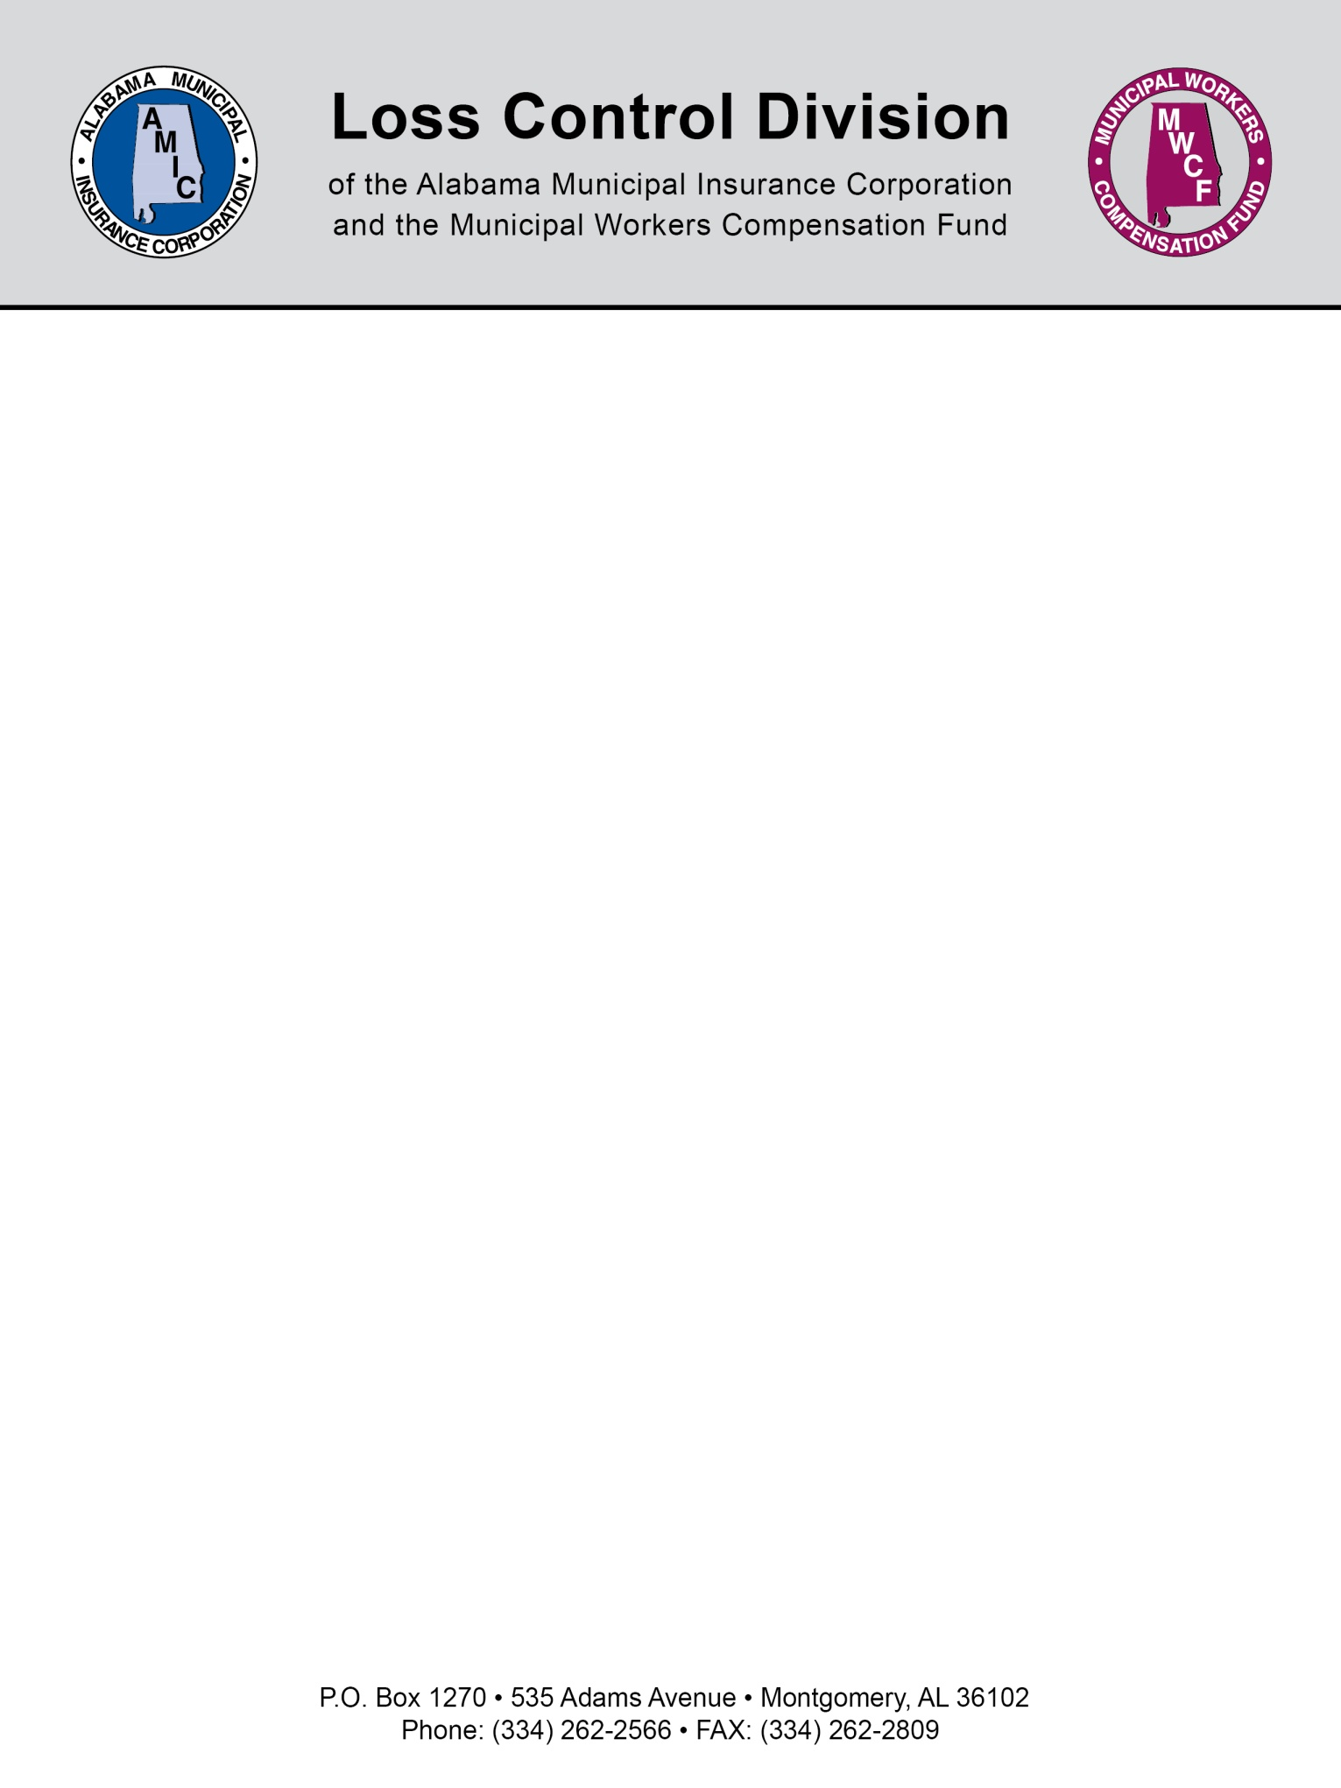

Contractor Liability Insurance Requirements

When selecting a contractor to perform a service you want to contract out, or you are just hiring a contractor for a small short term project, there are some important steps you need to perform to best protect your municipality from liability exposures related to that contractor’s actions.

Step 1: Always require that the contractor provides proof of their own liability insurance by requiring they submit a “certificate of liability insurance”. Any contractor that does not have their own liability insurance should never be hired.

Step 2: Require in writing that they maintain their liability insurance for the life of the project or contract. A certificate of liability insurance is only proof they have a policy in effect on the day the certificate is issued. They could cancel it the next day. That would mean they do not have any liability insurance during the actual project itself.

Step 3a: Require that the contractor adds your municipality as “an additional named insured” on their liability policy for the life of the project or contract. Also require the contractor’s insurance to be “primary” coverage over any insurance your municipality may have. This is the strongest protection you can get from liability exposures arising from the project or contract. In the event of a liability claim, it would now be their liability policy responding to defend the municipality rather than your own policy. You have truly transferred the risk away from the municipality.

For only the shortest of projects (including “emergency” contractors):

Step 3b: Although Step 3a is always the best protection, this may not be practical for very short term projects. For example, if a plumber is coming to fix a small water leak at Town Hall and will probably only be on site for a couple of hours; requiring step 3a is probably not realistic. However, that still doesn’t mean there aren’t some additional steps you can take that will help protect the municipality should a liability claim arise. With the help of your municipal attorney, you should draft a standard “indemnification and hold harmless agreement for contractors”. Some sample wording is provided below and you should then require this form be signed prior to the start of any work. This should also be required when you have to call and use a contractor in an emergency. This is certainly not an unreasonable request if the contractor wants your business.

Sample Indemnification and Hold Harmless Agreement:

“To the fullest extent permitted by law, the [Contractor] agrees to defend, pay on behalf of, indemnify, and hold harmless the [Entity], its elected and appointed officials, employees and volunteers and others working on behalf of the [Entity] against any and all claims, demands, suits, or loss, including all costs connected therewith, and for any damages which may be asserted, claimed or recovered against or from the [Entity], its elected and appointed officials, employees, volunteers or others working on behalf of the [Entity], by reason of personal injury, including, but not limited to, bodily injury or death and/or property damage, including loss of use thereof, which arises out of or is in any way connected or associated with this contract.”

NOTE: This document is not intended to be legal advice. It does not identify all the issues surrounding the particular topic. Public agencies are encouraged to review their procedures with an expert or an attorney who is knowledgeable about the topic. Reliance on this information is at the sole risk of the user.

Revised 1/2014

